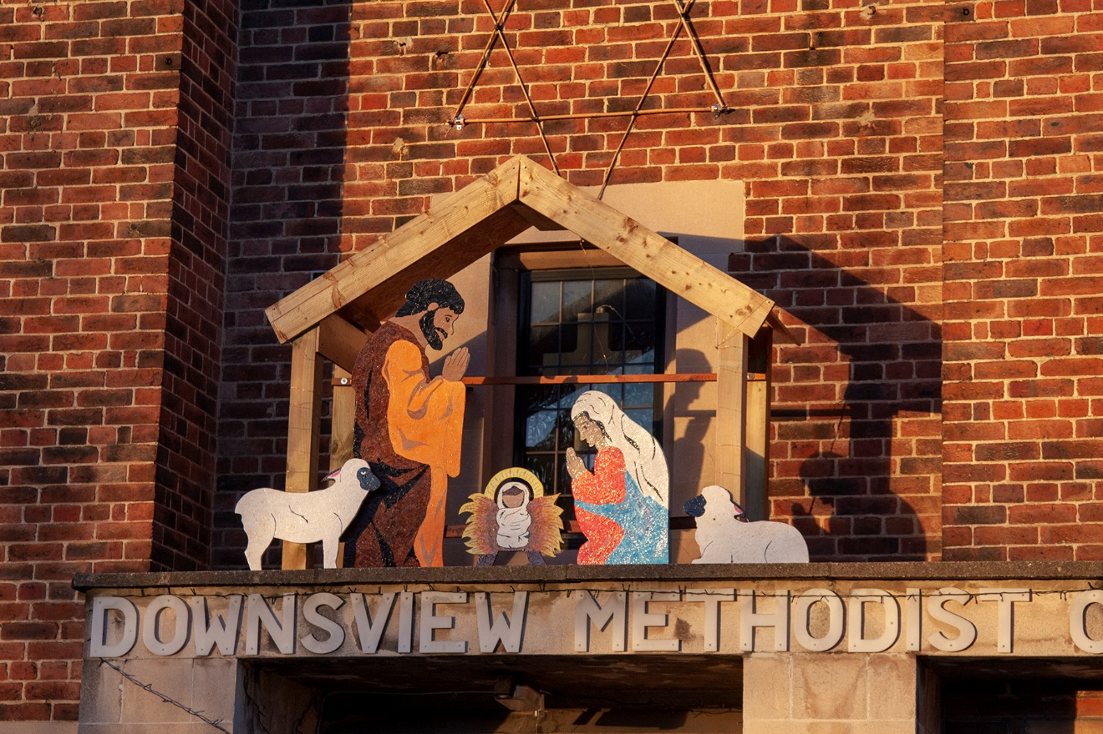

ACTORS AND CHURCH MEMBERS BUILD NATIVITY AND SANTA SLEIGH TO LIFT COMMUNITY’S SPIRITS

Members of an Upper Norwood amateur dramatics group joined forces with a church congregation to build a Nativity scene and Santa’s sleigh on Saturday (5 December) to brighten up their local community. And bring the love and light of the Christmas Story to life.
The Downsview Players and members of Downsview Methodist Church in Waddington Way Upper Norwood have spent weeks building the Christmas installations and buying decorations for an afternoon of celebration and charity giving on Sunday 20 December.
During the event, which will include a choir singing carols accompanied by All Saints Church Concert Band, people attending will be able to donate children and adult’s underwear, dried and tinned food for the Refugee Centre in Croydon, which is particularly needed this time of year.
The organisers will also collect shopping vouchers for carers working in care homes run by Methodist Homes for the Aged to thank them for all the great work they have done looking after some of the most vulnerable members of Croydon’s community.
Penny Fuller, from Downsview Church Council and 2nd Thornton Heath Girls’ Brigade Leader, said: “People within the Church and local community are weary of the Covid-19 restrictions and are feeling deflated so we wanted to do something that will lift everyone’s spirits at this difficult time.
“Even though the congregation and the Players have been meeting virtually, Downsview Church which is at the centre of the local community has appeared to be shut. So we wanted to also create installations full of light to let the community know we are still here for them.

“It will be such a lovely event with the car parks decorated as a Nativity scene with actors from the Downsview Players taking on roles for the afternoon, a Santa’s sleigh and a large Christmas tree – all decorated with multicoloured lights.
“After the first part of the carol service, people attending will walk down the hill with the Nativity actors past four Advent stations with the themes of hope, peace, joy and love, all of which have been decorated by local nursery children. In the bottom car park, the band will be playing around the Christmas tree.
“We deliberately combined the secular aspect of Christmas with the celebration of the birth of Jesus because of the importance they both place on love and giving.”
Due to Covid restrictions, spaces for the services are strictly limited and booked only in advance with a maximum of 44 people allowed to attend each of the four slots, starting at 2.30pm, 3.15pm, 4pm and 4.45pm on 20 December.
Anyone wishing to donate items of clothing, dried food or vouchers, but is unable to attend the services, can turn up at the church car park from 1pm to 2pm on the day.
Despite the lockdowns and restrictions, the churches have been holding services virtually and some members continue to help out at the Food Stop at Parchmore Church which supports low income families who receive up to 20 food items for a £3.50 weekly subscription.
The Downsview Players, who will be celebrating their 90th anniversary in 2021, have continued to meet virtually every Tuesday holding a variety of themed quiz nights as well as starting rehearsals for their next productions which have been postponed until next year.

